Basic Auth Policy
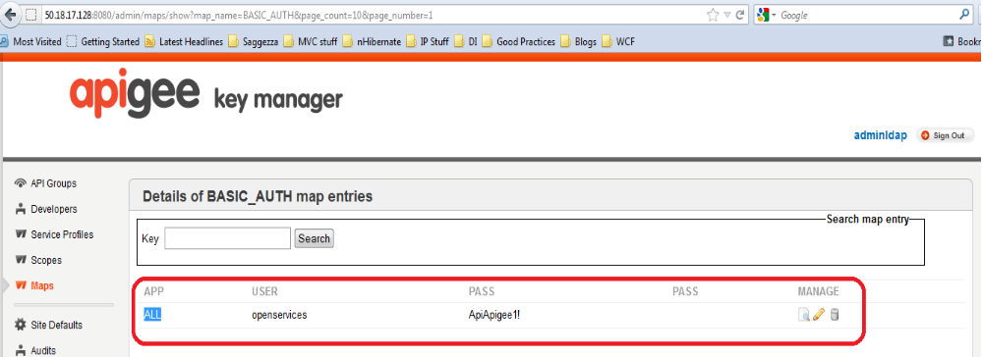
Basic Auth Policy is used at the target level. Targets are now protected by the Basic authentication profile. The IIS username/password for these, are stored in the KMS.
Apigee KMS map:

Below is the service call out we perform, in GetBasicAuth assertion.
http://50.18.17.128:8080/map/entry/attributes?map_name=BASIC_AUTH&key=ALL&cachekey=BASIC_AUTH_ALL

This endpoint itself is protected by username/password (apigee/apigee123). This is added on the basic_auth_target, GetBasicAuth operation in the target request using the policy, AddContent-TypeAndAuthorizationHeaderPolicy.

It uses the username and password from the AddContent-TypeAndAuthorizationHeaderPolicy itself. This is a configuration variable as shown below:
Devconnect Username/Password:
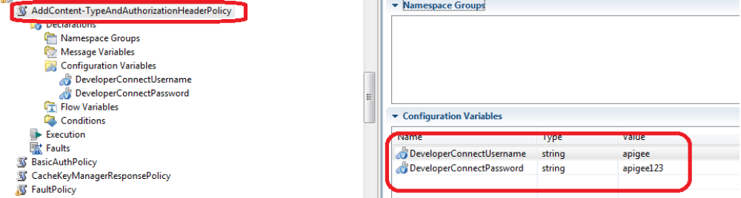
Once the service call out returns the IIS username/password, we perform a out of the box Credential mapping in the AddAuthHeaderForTarget assertion. Here we convert the basicAuth_user and basicAuth_pass into HTTP basic auth variables and this is attached on the target request to Redbox.
Basic Auth:
